AMN COVID-19 PROJECT REPORT
The Accra Mining Network organically funded the purchase of medical equipment and PPEs for the Simpa Health Centre in the Western Region of Ghana on April 25, 2020.
The items included 1 infrared Thermometer, 200 Surgical Masks, 7 liters of Nester Sanitizers and 4 boxes of gloves.
The Presentation
The items were presented by an Nkosuohene Nana Kweku Baah who is AMN Chief Metallurgist, and known in ordinary life as Ing Francis Donkor-Baah. The items were received by Medical PA in Charge of Simpa Health Centre, Dr. Samuel Larbi.
This is the second time the network is reaching out to the people of Simpa with a social intervention project. The first was in assisting the Health Centre in 2018 with a mechanized bore hole water supply system under the auspices of the Direct Assistance Program of the Australian High Commission to Ghana.
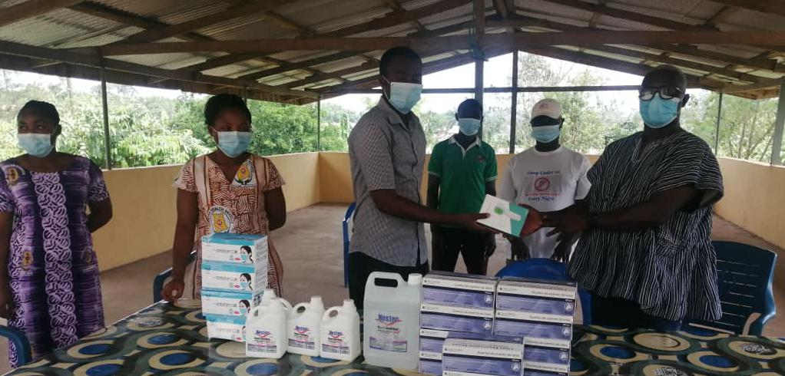
AMN presents items to Simpa Health Centre to help fight the spread of Covid-19.
THE COVID-19 PROJECT
The Covid-19 project concept was mooted by the Sub-Regional Coordinator of AMN, Mr. John Koomson and it received Executive Approval on April 10 with a target budget of GHS 2000 to be contributed by the Executives. Later it was agreed to widen the net and give the entire membership an opportunity to also contribute. A total of GHS 2950 was consequently realized to underscore the power in coming together and uniting forces as in the adage, little drops of water make a mighty ocean.
Source of funds
In an alphabetical order, the following is the list of AMN members who contributed funds, variously and severally to making the project successful.
- Abdul-Wadood Moomen
- Anthony Yaw Mensah
- Alexander Hagan
- Brenda Joyce
- Dennis Nii Sowah
- Edward Ordartey Mills
- Eric Enzula Bayari
- Festus Adomako Kusi
- Fedelix Kansake
- Florence Adu
- Georgette B. Sakyi-Addo
- Harriet Naakai Tetteh
- James Tampanga
- John Koomson
- Justice Amekudi
- Rev. Dr. Joyce Aryee
- Michael Djan-Sampson
- Nana Oforiwaa Arthur
- Nana Yaa Gyindoh l
- Diana Nkrumah
- Raymond Kudzawu-D'Pherdd
- Rosemary Oppong Kwasie
- Stephen L. A. Laryea
- Thompson Blay
- Utaz Adams
- Yvonne Marfoa Anokwa
Expenses
- Equipment: GHS 2380
- Miscellaneous/Media: GHS 150
- Dinah Nkrumah and Justice Amekudi facilitated the purchase and logistics.
- Spring Courier facilitated Accra-Tarkwa delivery, while Octagon Foundation assisted with Tarkwa Simpa delivery.

Message of Import
In an accompanying message, signed by the General Secretary, Mr. Raymond Kudzawu-D’Pherdd, the network on behalf of the Patrons, Rev Dr Joyce Aryee and Dr. Daniel Owiredu, and the President Mrs. Georgette Barnes Sakyi-Addo, expressed thanks to the membership for their contribution to putting the package together and prayed that it goes a long way in keeping the staff and the community safe as they go about their daily activities.
Concluding Observation
In the final analysis, it was heart warming to note that even members who were not in good standing with reference to their membership subscriptions or dues, sacrificed and contributed to this worthy cause in this time of need. In the superior wisdom and judgement of the Executives of AMN, this is the best initiative of the network that has received tremendous and enthusiastic support from members voluntarily. So Congratulations to all. AMN-Come, Learn, Earn.
End of Report
An April 26, 2020 Gazette

